

**HOLIDAY FUNSHEET 2**

**NAME: DATE OF ISSUE:**

**ROLL NO: DATE OF SUBMISSION**

I.FIND THE MISSING LETTERS :

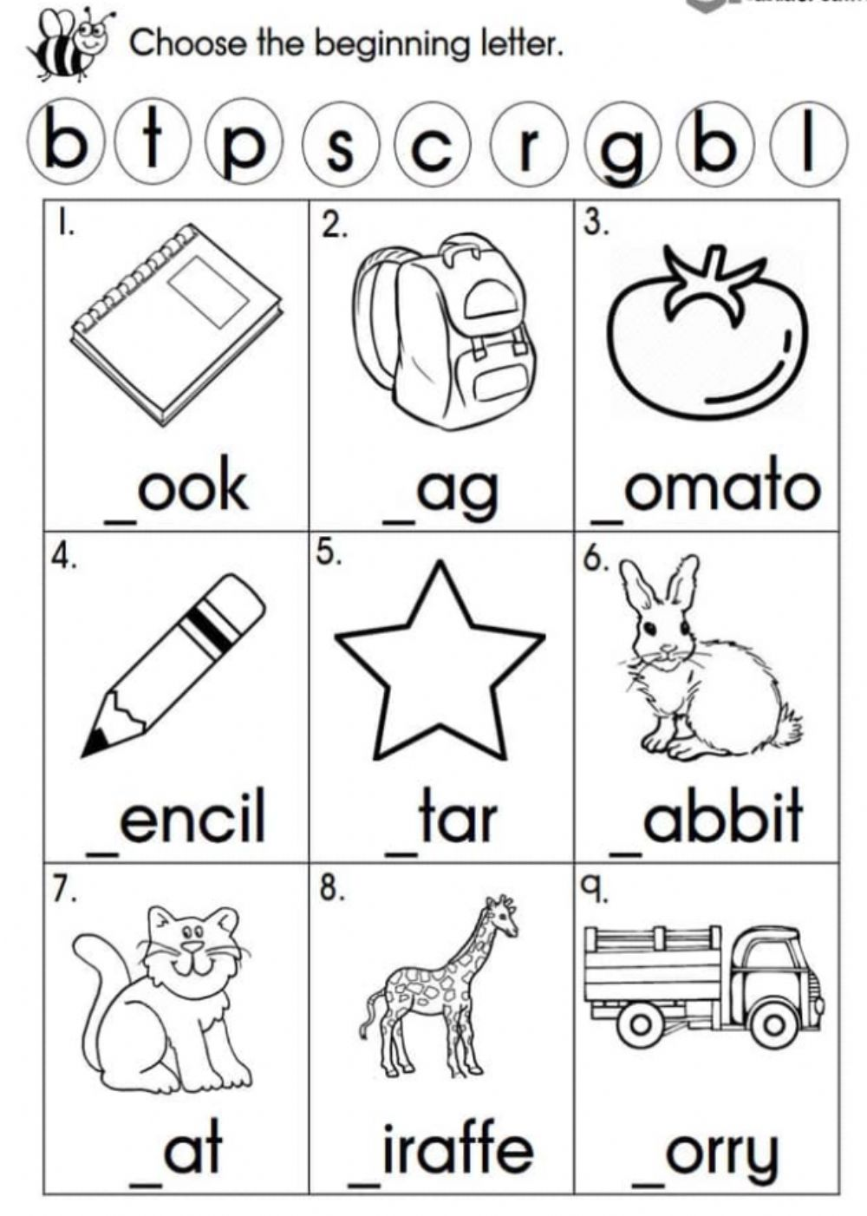

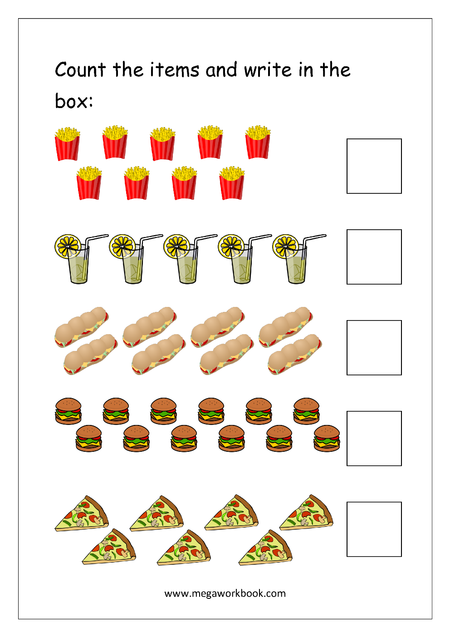

III.

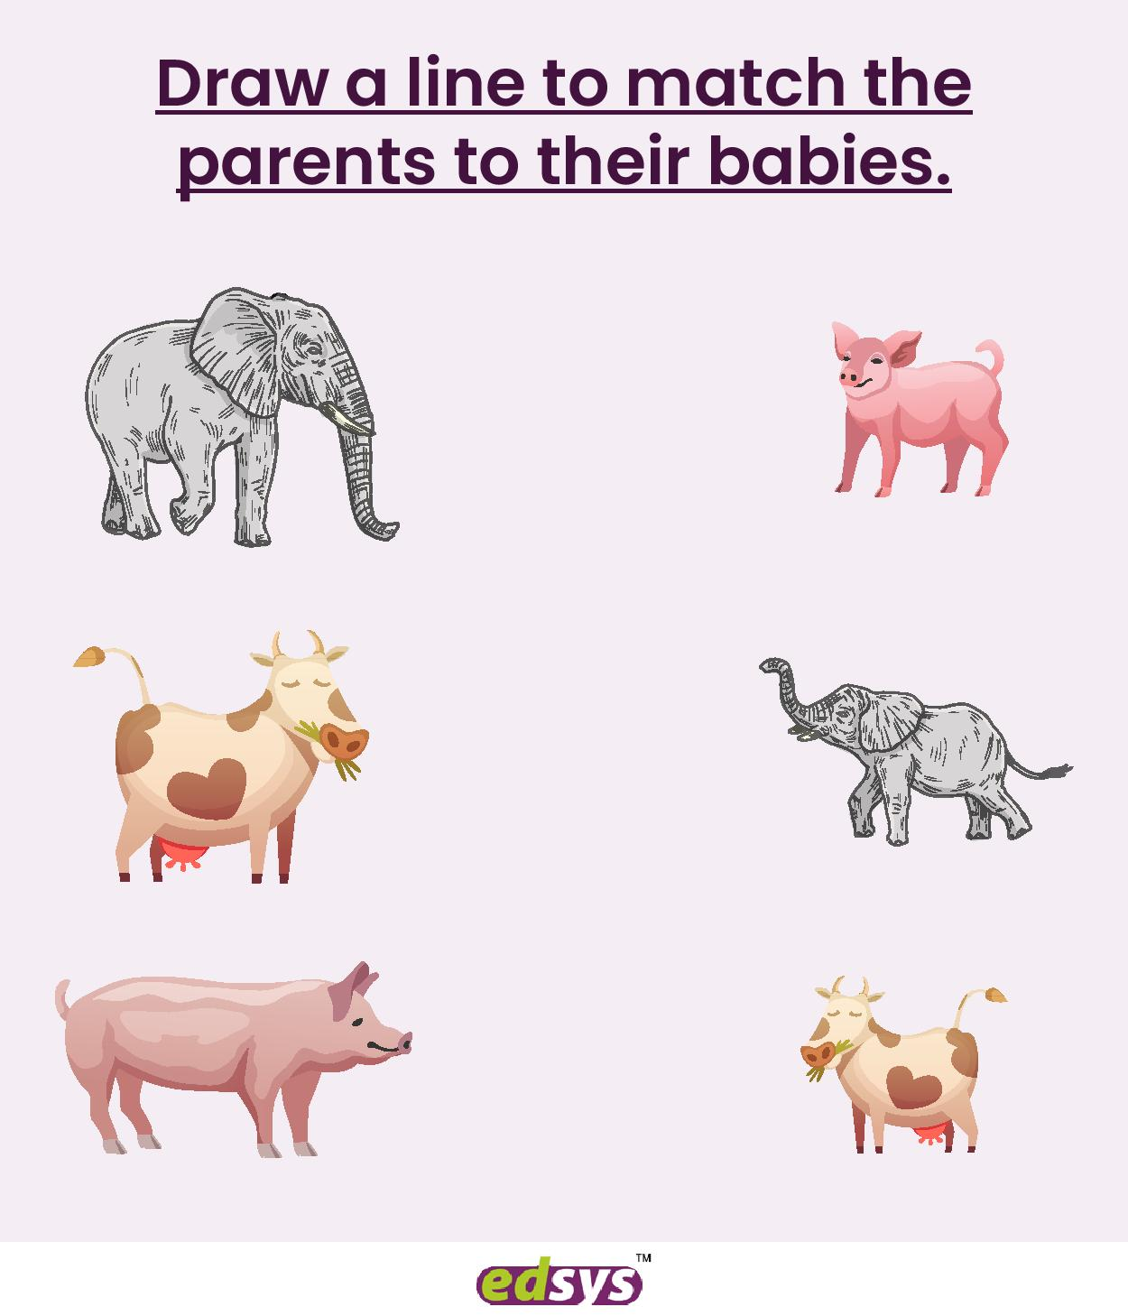

**IV. BY USING CLAY MAKE A COLOURFUL BUTTERFLY:**

